Ipad的Duet软件的连接

解决办法：

进入设备管理器，卸载该Apple Driver驱动。

此电脑-->右击—>设备管理器-->通用串行总线(端口)—>Apple Mobile Device USB Driver-->删除该驱动。

然后用USB连接ipad，自动重装了该驱动，就连接上了。

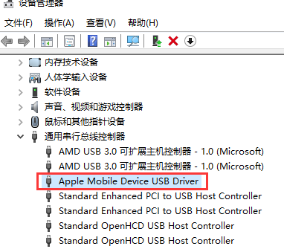

Duet官网：<https://www.duetdisplay.com/>

可以下载Mac和PC对应的软件。

点击最下面的Help Center：



<https://help.duetdisplay.com/>

搜索apple driver：

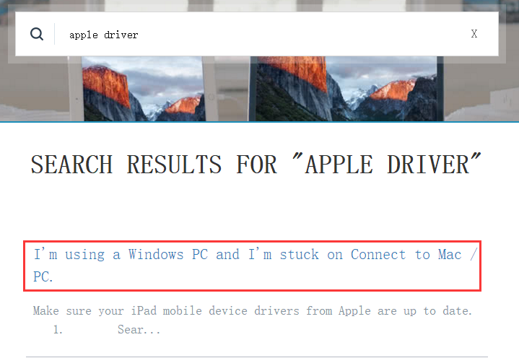

打开第一条：

<https://help.duetdisplay.com/faq/i-m-using-a-windows-pc-and-i-m-stuck-on-connect-to-mac-pc?from_search=25581229>

I'm using a Windows PC and I'm stuck on Connect to Mac / PC.

Make sure your iPad mobile device drivers from Apple are up to date.

1. Search Device Manager and open the application

2. Go to Portable Devices and find your iPad or iPhone

3. Right click and select "Update Driver Software"

4. Then select Browse this Computer and go to **C:\Program Files\Common Files\Apple\Mobile Device Support\Drivers or C:\Program Files (x86)\Common Files\Apple\Mobile Device Support\Drivers**

5. Click Next

6. Windows should find the updated driver and update it. You should be able to see your iPad or iPhone available to sync in iTunes now. However if the driver doesn't update and Windows says you are up to date you will need to uninstall the driver and reinstall it. Feel free to contact us for help.

7. Now connect Duet.

Video instructions of this workaround: https://www.youtube.com/watch?v=vkG9NfKR1DA

More instructions and recommendations to fix issues with Apple device support on Windows PCs.

https://support.apple.com/en-gb/HT204095